Travel Agency Report

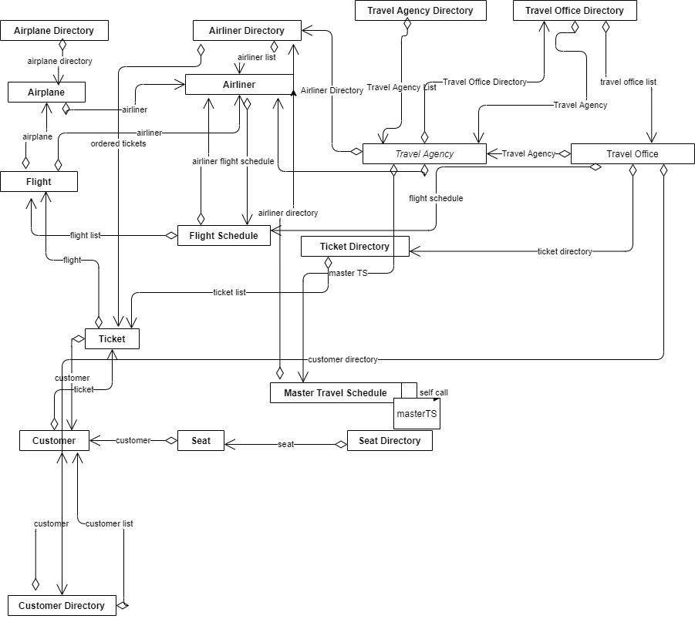

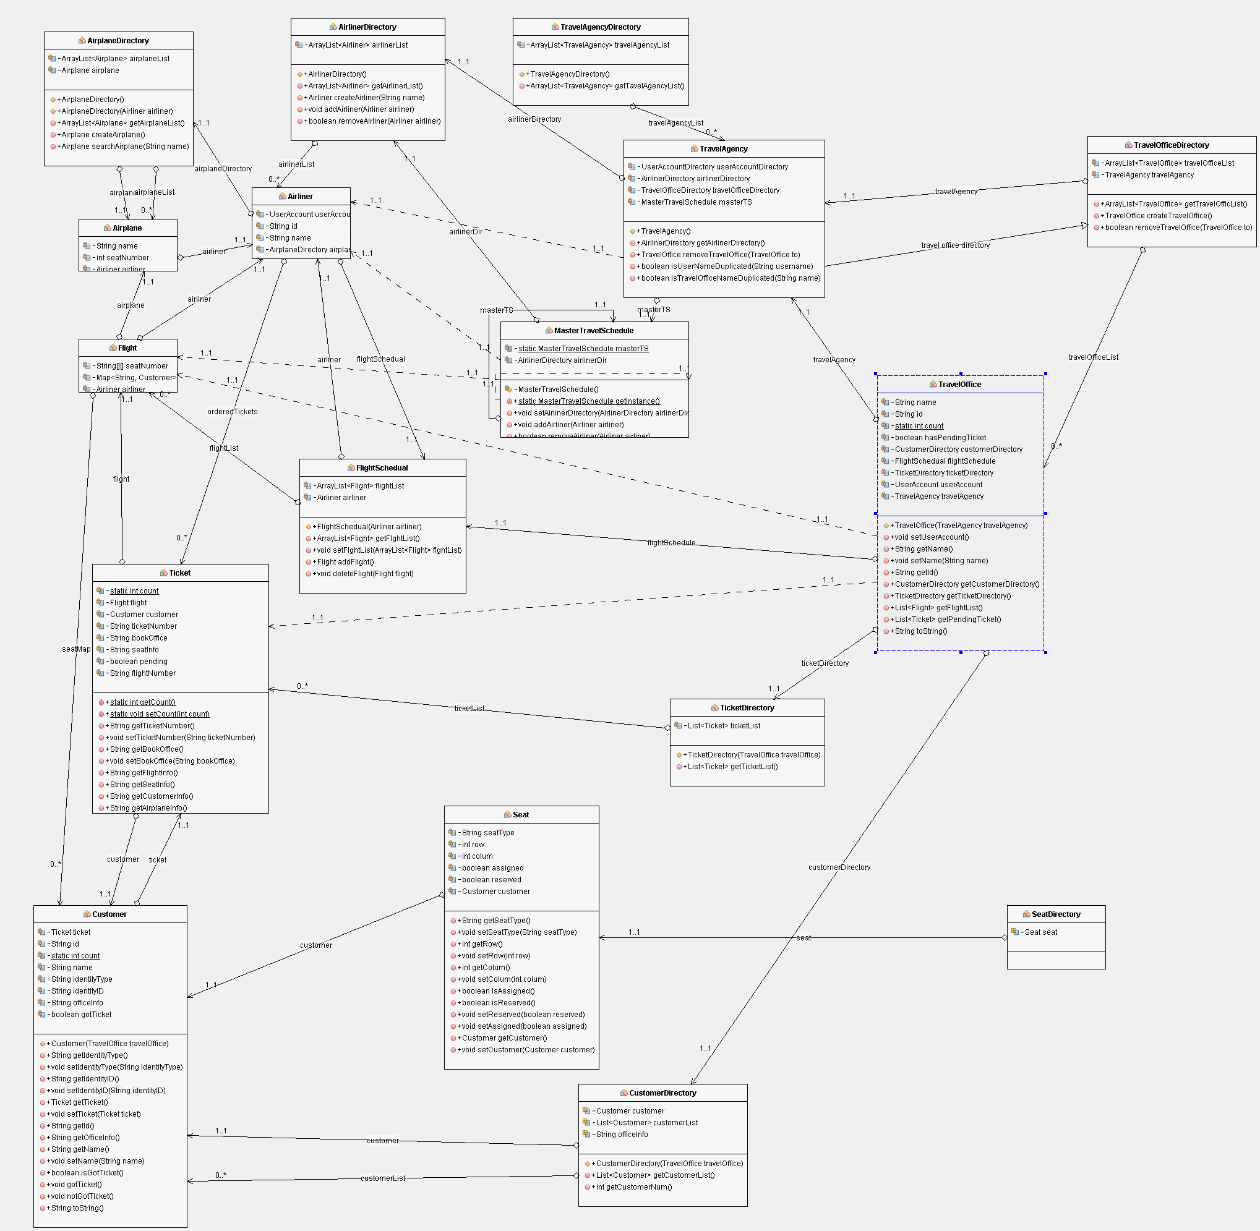

Car Rental System

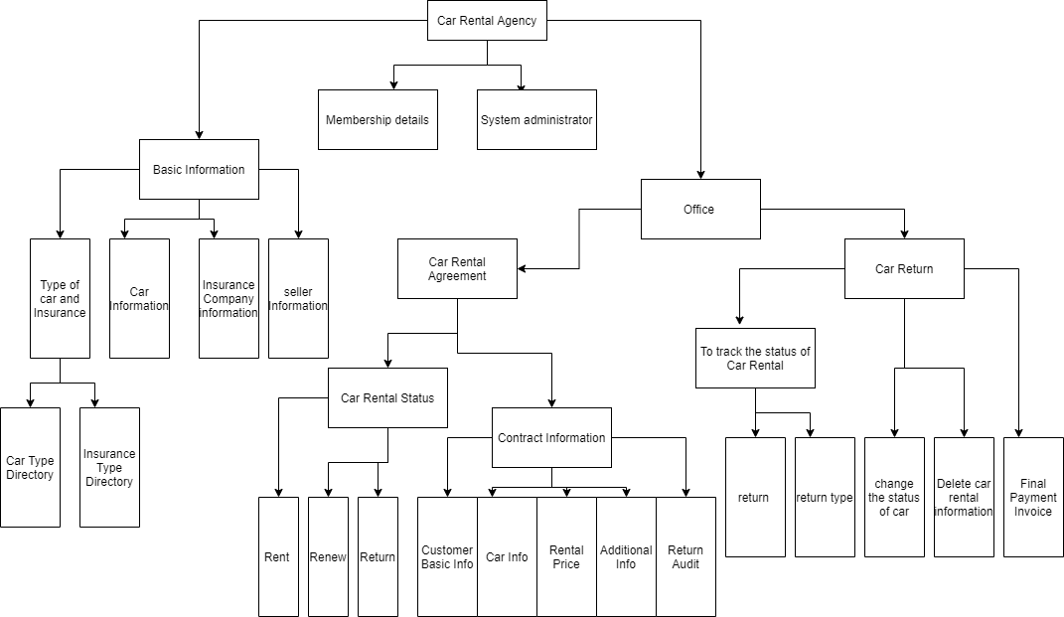

**Car Type Directory:** System administrator can operate on car type (car name and detailed description)

**Insurance Type Directory:** System administrator can operate on car insurance type (the name of insurance and the detailed description).

**Car Rental Agency:** Car rental agency have all the information about office.

**Office:** Office looks over all the rental agreements, car rental status and many more things.

**Contract Information:** It will contain all the basic information about customer, car, rental price agreed upon etc.

**Car Rental Status:** This checks whether the car is renewed, returned or still in the rental period.